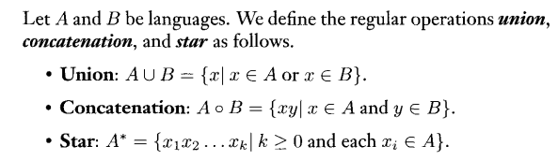

Note: Class of Regular Languages is closed under Regular operations listed above. It is also closed under Complement operation. If Lang. A is regular, then so is A-Complement. Also Closed under Intersection

**Convert NFA to DFA:**

* Start at start state(s) and label these. Take care to follow any Epsilon transitions.
* Then Label the next states by looking at all possible states one can go to from the labels of the current state and for a given observed symbol. DON’T FORGET EPILSON
* 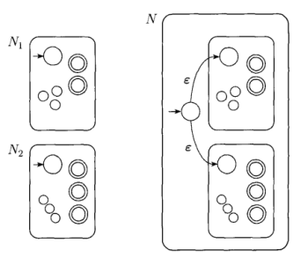Also Follow ALL Epilson Transitions encountered after reading & processing a given symbol to enlarge the set where appropriate.
* If DFA state contains an accepting label from NFA, make that state acc.

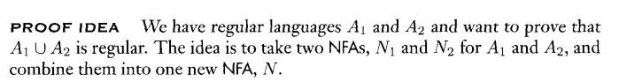**Proof that Regular Languages Closed under Union:**

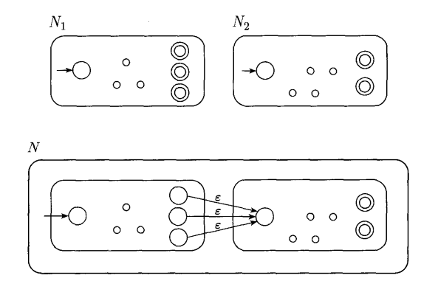**Proof that Regular Languages Closed under Concatenation**

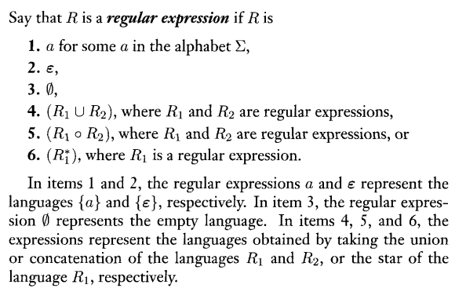

**GNFA: Same as NFA but…**

* Transitions labeled with regular expressions
* 1 start state and 1 accept state
* Transition is present for EVERY pair of states exept:
  + NO transitions INTO start state
  + NO transitions OUT of accept state

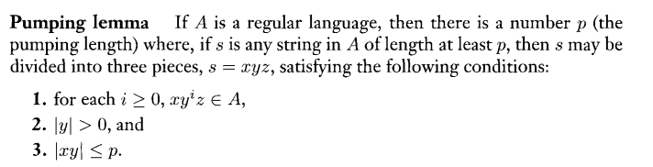

**Converting CFG to PDA**

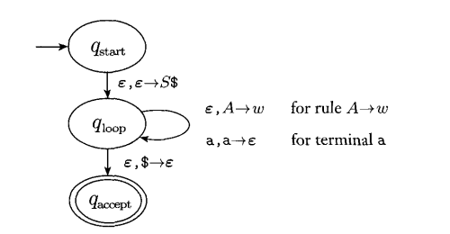

**Sample question:**

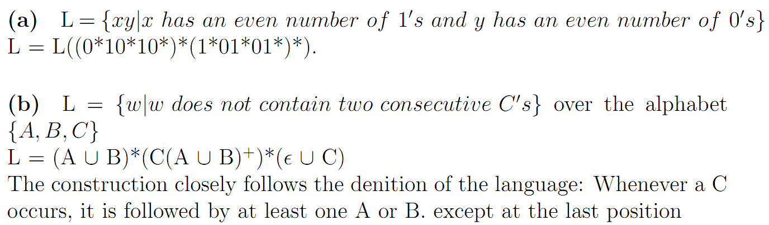

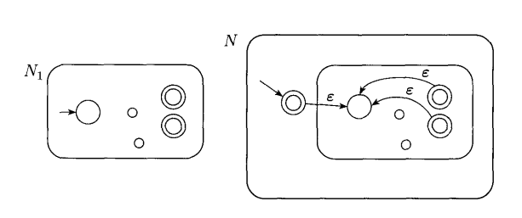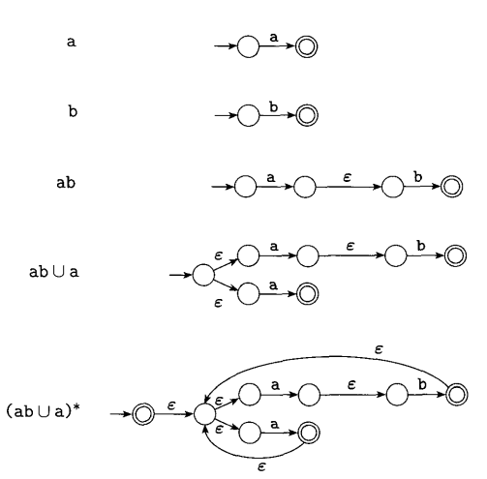**Converting a Regular Expression t** **o an NFA Example**

**Construction to Recognize L* (Kleene Star)**